Office Pro Academic 2013 Activation SOP
- Go to Start and select “Excel 2013”
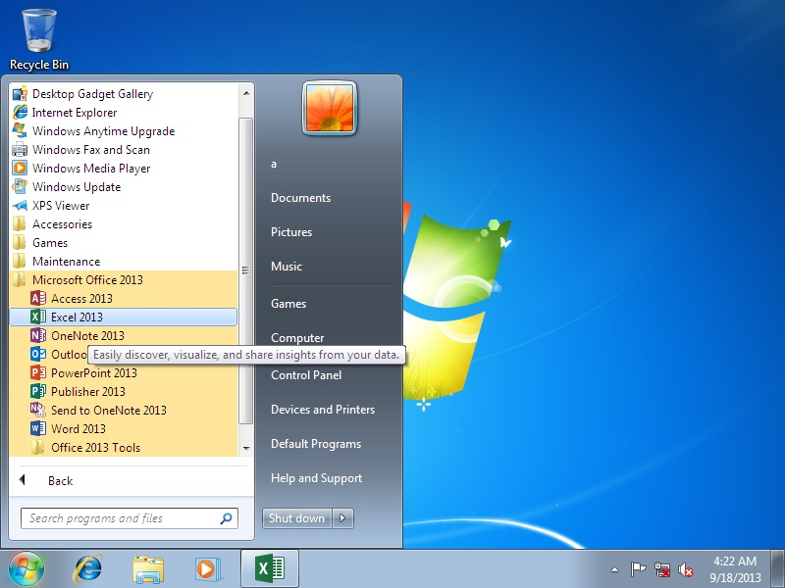

- You will find the MPI card on the accessory box like attached.
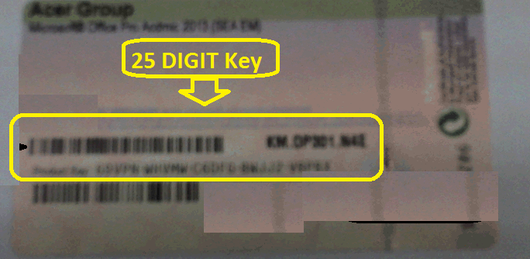
- Key in the 25 digit license no from MPI card on the below Window and click continue
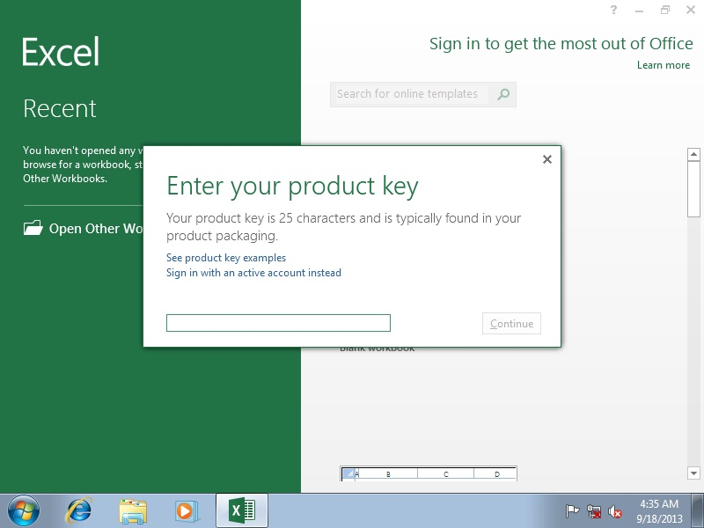
- Connect to internet and activate or activate later once internet is connected 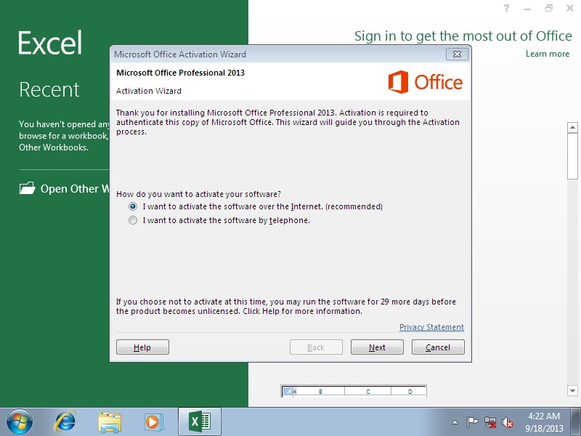

- End

